Design Validation Form (DVa)

TTC LINE 2

APPROVAL
 | Role/Job Title | Name | Date and Signature
Written by | SEM  (Solution Engineering Manager) | Mansour Khan
Written by | PDA  (Project Design Authority) | Gerhardt Hauer
Verified by | VP, Engineering | Vincent Bourget
Verified by | SA  (Safety Authority) | Bruce Stenzel
Approved by | DA  (Design Authority) | Rudy Rochefort

LOG OF CHANGES
Revision | Date | Author | Change Description
001 | Sept 15 2025 | G. Hauer | First release
002 |  | G. Hauer | Post Gate 2
003

Contents
1. APPLICATION 7
2. BACKGROUND & RATIONALE 8
Main evolutions since previous signed DVa: 8
Customer Context & Objectives: 8
Solution Description: 9
Customer Needs 11
Operational Concept 11
Solution Description 12
Main Deliverables to the Customer: 16
Key activities used to validate the solution: 16
Internal reviews: 16
List and reference sub-systems DVa: 17
3. ASSESSMENT, ISSUES & RISKS 18
A. REQUIREMENTS: 18
B. SOLUTION, PRODUCT POLICY AND INNOVATION 19
Product HSE: 19
Environmental Footprint Improvement 19
C. SECURITY: 20
D. SAFETY 22
E. HUMAN FACTORS, ENVIRONMENTAL CONDITIONS, LEGAL CONSTRAINTS AND PERFORMANCE 24
F. ENGINEERING COVERAGE AND SPECIAL EXPERTISE: 25
G. SCHEDULE, WORKLOAD AND COST: 26
H. RISKS/OPPORTUNITIES: 29
4. SUMMARY, DECISION & ACTION PLAN 31
DVa «VALIDATED with Action Plan»: 31
Actions to be addressed for Gate 2: 31
1. Decide on incorporating Hitachi Vienna Eurobalise to save platform dev costs (approximately 3 MCad savings). 31
2. Finish the compliance assessment outline clear plan for non-compliances and smart compliances. Producing a grouping to ensure. Put the listing in an Appendix (Excel File preferred) 31
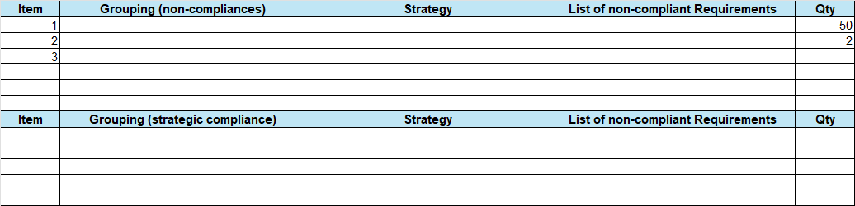 31
3. The bid has not taken into account Arema requirements which are required as part of the RFP. Recommend to have the following to balance compliance with competitiveness. 31
a) Provide in the project cost a nominally Arema compliant solution – after all, most of our platforms and equipment being delivered for Crosstown meets Arema. 31
b) For the remaining non-compliances, put the cost-comply in risk. 31
c) Ensure a complete and detailed estimate for the work needed ‘to comply’. 31
4. Additional float to be built into the schedule in particular for initial PDR and IDR milestones. The CDRL list to be reviewed to ensure reasonable and appropriate (for the phase) are allocated to these milestones. 31
5. Resolve the discrepancies in the feature list and their related estimates. Resubmit the feature list Excel with 2 pivot tables for final review and Design Authority approval. 31
6. Include in conditions of offer: Responsibility for the private frequency license is with Customer. 31
7. Minor cleanup: Architecture diagram change from Cisco Radio to 5G radio. 31
Main points of attention for Gate 2: 32
Main outcomes of DA assessment 32
Appendix A: Trackside Devices 35

List of Tables
Table 1 Summary of Baseline to be used for each Subsystem 19

List of Figures
Figure 1 : High Level Project Roadmap 28
Figure 2 : Engineering Labour Summary 29

APPLICATION
Reference: | TTC Line 2 DVa R01
Type & Classification: | Resignalling - C2
Step: | Gate 2
Bid/Project/Product Name & ID: | TTC L2
Solution Level: | System
Solution Name: | SelTrac CBTC
Solution description: | Replacing the existing Line 2 fixed block system with a CBTC system
Key Products/Solution: | SelTrac CBTC 3.7, DCS 3.4, OAMS 1.3, OPUR 2.4, Hitachi Reduced Size Eurobalise® Transponder, Frauscher Axle Counter system [procured]

BACKGROUND & RATIONALE

Main evolutions since previous signed DVa:
Not Applicable, first revision.

Customer Context & Objectives:
TTC L2 is 26.2 kilometres long and runs East/West across the city of Toronto from Kipling Station to Kennedy Station, with a total of 31 stations along the line. Yards are located at Greenwood and Keele. There is approximately 55 km of total track. The mainline has 17.9 km of single box tunnel, 1.8km single bored tunnel and 7km in open air (includes line end turnback and storage tracks).
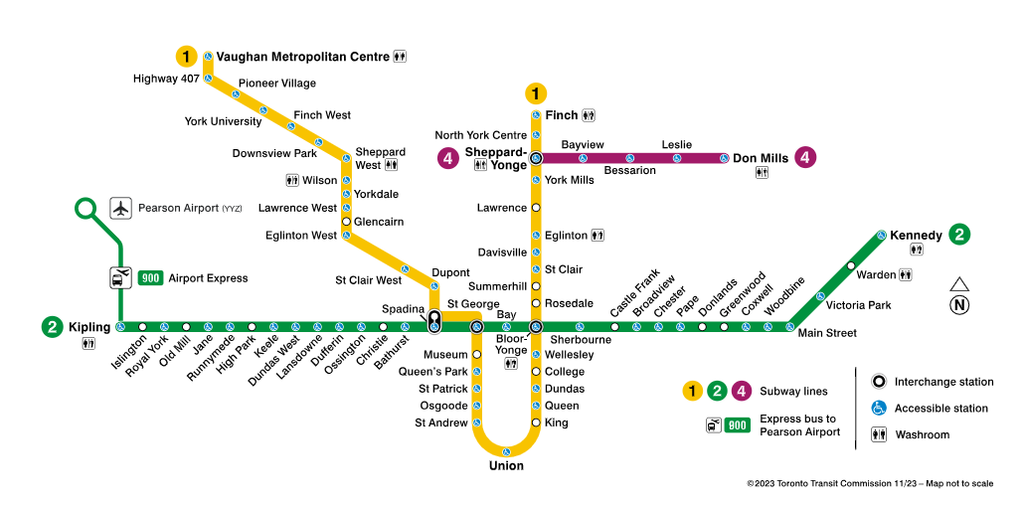
The existing system is a fixed block signalling system that opened in 1966 that the customer wants to modernize by replacing the legacy signalling system with a new ATC system to support increased ridership, and improved reliability and availability.
This is a direct contract to TTC for all scope except for the SSE extension option, which will be a contract with Metrolinx.
One of the key objectives for the customer is local content which will be pushed as a strong differentiator for us.
Main competitors are Alstom (supplier of Line 1), and Siemens.
Customer’s Evaluation Criteria has 4 stages:
Stage 1: Prequalification
Stage 2: Cybersecurity Assessment
Stage 3: Commercial Confidential Meetings/Technical
Stage 4: Final Submission
The Technical Submission in stage 4 provides 750 points and has a 65% weighting.
There will be new contracts for the following, not in scope of the Rehabilitation program, but running in parallel and with dependencies and interfaces to it:
- Speed Control System for 70 trains, same NTP, 50 month duration; as per requirements, no synergy in solution is allowed.
- Scarborough wayside extension conventional signalling, compatible with existing Line 2 Speed Control System (SCS).
Hitachi Rail is the designated supplier for these 2 contracts.

Solution Description:
System
CBTC system, designed for DTO or GoA3 operations. The normal mode of operation for passenger carrying trains on Line 2 shall be GoA2.
The CBTC system on Line 2 will be designed to support (One person train operation) OPTO as well as two-person operation (operator plus guard). It is expected that when the Line 2 CBTC system is fully operational, OPTO will be the primary type of operation. The OPTO control system allows the guard (on board attendant) control from a middle car on the train.
For GoA3, at stations without GIDS or PSDs the on-board attendant (guard) will press the ATO depart button to permit the CBTC-equipped train to depart the station.
The long term vision has GoA4 UTO planned for future TTC yard upgrades which will be designed for GoA4 operation.
Passenger trains support ATO, CABS/ATPM, RMF, RMR, and EM (cutout) modes. Work trains can support up to ATPM.
Transit Control Centre (TCC) and Backup Transit Control Centre (BCC) are to be provided. Both the TCC and BCC will have redundant central equipment. ZC will be centralised with 2x2oo2 redundancy at each central equipment room.
The system will have external ATS to CSS (legacy ATS) and Interlocking interfaces to various interlockings and existing ATS. The interface to the legacy interlockings are not known and our solution is based on using simple discrete IO to implement the portal handling in the product design with some location specific adjustments. The ATS-CSS protocol is also not known and our solution is based on all CSS’s having the same protocol (TTC will use the same SW firm for all systems) so we will only need one protocol with the telegram contents catered per location and CSS.
- Line 1 for train and Work Car transfers between lines at Bay Lower Station and Spadina Ramps
- Greenwood Yard for train and Work Car transfers between the mainline and the non-CBTC depot
- Existing Line 2 systems for train and Work Car transfers at migration boundaries between CBTC and legacy areas
- SSE for train and Work Car transfers at the boundary between Line 2 CBTC and the SSE system. This will be a temporary migration boundary if the Metrolinx option to equip the SSE with CBTC is exercised (most likely).
Unified Diagnostic and Maintenance System (UDMS) consisting of SelTrac OAMS, NMS and HMS components.
Cutover cubicles (COC) will be used in each SER to facilitate testing and commissioning.
The COCs and external interfaces at migration boundaries will be decommissioned after revenue service commences.

Deployment Scope
Design and supervision of installation, perform test and commissioning.
Installation of cable in SERs and PICO of all cabling.
Decommissioning of cutover cubicles, ETT and any other temporary equipment.

Warranty and Long-Term Maintenance
Three (3) years warranty from the Phase 6 Cutover Date.
Long Term Maintenance (LTMC) 3 years in length starting at the end of the warranty period. One year LTMC price to be provided and further LTMC extensions to be renegotiated for the life of the Work.
Additional six bid options are required:
- 7 additional new subway trains (NSTs)
- 4 additional new subway trains (NSTs)
- Test and Commissioning, and Supply of interfaces required for control and supervision of Platform Edge Doors (PEDs) at all passenger stations
- Test and Commissioning, and Supply of interfaces for supervision to Guideway Intrusion Detection Systems (GIDS)
- 5 years Long Maintenance Contract (LTMC)
- Metrolinx contract for design, supply, test and commissioning, and safety certification of CBTC for the Scarborough Subway Extension (SSE)
  - Note that TTC has left PEDs for the SSE out of the revised specification. Although there is still an old answer to a question that states that the SSE should include PEDS, addendum 11 overrides this.
  - This provides an opportunity to obtain a variation order for implementing PEDs on the SSE.

Customer Needs
Customer has proposed 6 geographical phases for the installation, testing and commissioning and cutover of Line 2. Revenue is planned in 6 stages as follows:
Phase 1: Kennedy to Main Street including Central, MTT in Greenwood, and radio coverage in Greenwood Yard
Phase 2: Main Street to Donlands (including Greenwood Wye and Hostler Platforms)
Phase 3: Donlands to Yonge
Phase 4: Yonge to Bathhurst
Phase 5: Bathurst to High Park
Phase 6: High Park to Kipling
An alternative migration strategy to reduce the number of stages to 3 has been considered; however, it cannot be proposed since it is not fully compliant. A ROM estimate has been made to potentially use the alternative should the opportunity arise during negotiations.
Key TTC requirements and constraints (list is not exhaustive):
- Design Headway of 90 seconds and Operational Headway of 135 seconds.
- Transit Control Centre (TCC) and Back Control Centre (BCC)
- Six migration stages (see above for alternative strategy)
- Centralized ZCs
- Reuse existing switches and provide new signals, trip stops and ACBs. See appendix A for quantities.
- Interface to Line 1 Signalling System
- Eurobalise for transponders
- Frauscher axle counters
- Red Signal Overrun (RSO) protection, requiring Trip Stops to be supplied
- Web based ATS Workstations (WBATS), accessible from any TTC IT workstations
- Compliance to many Cyber Security Standards, zero trust improvements and interfacing with external SOC
- Many TTC specific features requiring modifications to product and new functions
- Separate WAN required for testing
- Many work train types, some variable length with trailers
- Unified Diagnostic and Maintenance System (UDMS)

Operational Concept
The normal mode of operation for passenger carrying trains on Line 2 shall be GoA2.
For GoA3, at stations without GIDS or PSDs the on-board attendant will press the ATO depart button to permit the CBTC-equipped train to depart the station.
The plan is for GoA4 UTO (Unattended Train Operation) in future TTC yards designed for GoA4 operation.
The trains will have a Guard Control Panel on each car for an on-board attendant to control doors and press an ATO depart button to permit the CBTC-equipped train to depart the station.

Solution Description
Resignalling of TTC Line 2 Mainline (26.2 km), with 31 stations and storage yard at Keele. Engineering Test Track (ETT) at Wilson Yard and Maintenance Test Track (MTT) at Greenwood Yard.
SelTrac CBTC V3.7
The system includes:
- 2x2oo2 VOBCs per train, 1x2oo2 for Work Cars
- DCS 3.4 with 5G radio
- Eurobalise Transponders, from Hitachi Italy, Tito Scalo Plant
- No Proximity Plates, based on improved positioning accuracy from Eurobalise transponders
- Centralized ZCs
- Test DCS Network
- MCGs in SERs for room level Zero Trust enforcement
There are external interfaces to:
- Line 1 CSS(legacy ATS) and Interlocking for train and Work Car transfers between lines
- Greenwood Yard CSS and Interlocking for train and Work Car transfers between the mainline and the non-CBTC depot
- Line 2 CSS and Interlocking for train and Work Car transfers at migration boundaries between CBTC and legacy areas
- SSE CSS and Interlocking for train and Work Car transfers at the boundary between Line 2 CBTC and the SSE system. This will be a temporary migration boundary if the Metrolinx option to equip the SSE with CBTC is exercised (most likely).
- TTC systems:
  - SCADA
  - Next Train Arrival System (NTAS)
  - Passenger Information and Announcement System
  - Mimic Server
  - TTC IT workstations, for Web Based ATS (WBATS) WS
  - Trapeze TTC scheduling program
  - TTC GPS Master Clock
  - INFORMATION REPOSITORY (IR)
  - Network Archive Server (NAS)
  - SOC / SIEM

Figure 1 : System Architecture

Figure 2 : Central Architecture

ATS
The ATS will be based on SelTrac 3.7 with TTC specific NRCs described in the Requirements section below.
The ATS and thin client Control Center workstations will be located at the Transit Control Centre (TCC) and Backup Transit Control Centre (BCC). All ATS servers will run as VMs on the Hitachi Data Centers.
The ATS will have external interfaces to existing CSS (legacy ATS) systems for handovers to the Line 1, Greenwood Yard, migration boundaries and the SSE. External Interfaces to the following TTC systems will also be included:
- SCADA
- Next Train Arrival System (NTAS)
- Passenger Information and Announcement System
- Mimic Server
- TTC IT workstations, for Web Based ATS (WBATS) WS
- Trapeze TTC scheduling program

Wayside
The ZC will be based on SelTrac 3.7 with TTC specific NRCs described in the Requirements section below.
ZCs will be centralized.
Remote IO will be located in specific SERs provided by TTC.
The ZCs, via OC-UR will have interfaces to external signalling systems at Greenwood yard the portals to Line 1 and the Scarborough Subway Extension (SSE). Temporary Interfaces to external signalling system at migration boundaries for revenue trains to travel between CBTC to legacy systems.
Cutover cubicles and temporary external signalling system interfaces at migration borders will be used for system migration. These will be decommissioned after revenue service commences.
Some system elements are imposed by TTC requirements. We must use:
- Frauscher axle counter system for Secondary Train Detection
- Eurobalise transponders
- Mechanical Trip stops for Red Signal Overrun (RSO)

Onboard
The VOBC will be based on SelTrac 3.7 with OP-UR 2.2 and TTC specific NRCs described in the Requirements section below. The solution team has proposed using an Eurobalise Tag Reader from Hitachi Italy, this tag reader requires modifications to OP-UR 2.2 to support the interface. These modifications will be included in OP-UR 2.4 which will be injected in the TTC L2 project stream without requiring the solution level re-certification of SelTrac 3.7.
Equipping 55 passenger trains, 35 fixed length work cars and 3 locomotives (combined in various configuration) with VOBCs. Locomotives may be coupled with trailer cars.

Diagnostics
The Unified Diagnostic and Maintenance System (UDMS) consists of the SelTrac OAMS, NMS and HMS. This will be supplemented with detailed diagnostic information from the Frauscher axle counter system and the DCS products’ Element Management Systems (EMS).
The OAMS will be based on OAMS 1.3 and TTC specific NRCs described in the Requirements section below will be included in a future version of OAMS aligned with TTC L2 schedule.
The NMS will be a new Integrated NMS, based on Opentext, the same as proposed for the Fulton Bridgeland bid, limited to TTC specific needs.
External Interfaces to the following TTC systems will be supported:
- Remote UDMS workstations
- Maintenance server (MAXIMO) application Interface for asset monitoring, management, maintenance and reliability planning.
The Frauscher axle counter system has a Frauscher Diagnostic System (FDS) that includes local data logging and diagnostic computers. This can interface with the central ATS and UDMS via an XML interface to upload status and event logging data. The UDMS and ATS will display high level status, analytics and alarms. The FDS will be accessed locally in each SER with Frauscher maintenance terminals used for detailed troubleshooting and maintenance.
DCS
The DCS will be based on DCS 3.4 with TTC specific NRCs described in the Requirements section below and detailed in the DCS DVa.
5G Radios will be used with a private 5G network. The 3900-3980 Mhz spectrum will be utilized under the Canadian Non-Competitive Local Licensing (NCLL) framework. Applications for spectrum licences for the 5G band must be made by applying to Innovation, Science and Economic Development Canada (ISED). The application must be requested by TTC and will be completed with Hitachi’s support.
As a condition for using private 5G, Passive Inter-Modulation (PIM) testing is required. Specialized COTS PIM testing equipment will be provided.
The DCS will support external interfaces to the following TTC systems for system, IT and Cyber services:
- TTC GPS Master Clock
- INFORMATION REPOSITORY (IR)
- Network Archive Server (NAS)
- SOC / SIEM
A diagnostic data archive server will be provided, which will be in the DMZ to allow TTC to have access to the archived diagnostic data.
External interfaces required for ATS and UDMS (OAMS) functions will also be supported.
A Test WAN will be provided to isolate all test network traffic from the revenue WAN and use central equipment in the BCC for testing. This minimizes the risk of affecting revenue service and allows testing to be performed in during revenue service (if allowed by TTC). This will be implemented as a Logical WAN sharing the DCS backbone (i.e. a second physical WAN is not required), with switchover handled by a new DCS Deployment.

Main Deliverables to the Customer:
- CBTC system capable of ATO operations in mainline and depot
- CBTC VOBCs for Passenger Trains and Work Cars
- Design files consistent with standard GTS deliveries
- Production hardware
- Support

Key activities used to validate the solution:

Internal reviews:
NRCs and RC Variable cost drivers have been reviewed with subject matter experts, Duka Krunic and Dave Dimmer.
A performance analysis has been done to ensure we can meet the headway and travel time requirements.
Site Visit:
A one day visit was allowed to survey Transit Control Centre at Hillcrest Complex, Victoria Park Station Signal Equipment Room (under Construction), Kennedy Station – Scarborough Subway Extension (SSE) – Signal Equipment Room, TTC Work Cars located at Davisville Yard – Davisville Station.
Detailed reports are saved here:
CA-GTS-URS Bids > Documents > Individual Bid Folders > NORAM > CANADA > TORONTO > TTC > TTC Line 2 > 60.30 Solution Data > Survey
https://urbanandmainlines.sharepoint.com/sites/CA-GTS-URSBids/Shared%20Documents/Forms/AllItems.aspx?id=%2Fsites%2FCA%2DGTS%2DURSBids%2FShared%20Documents%2FIndividual%20Bid%20Folders%2FNORAM%2FCANADA%2FTORONTO%2FTTC%2FTTC%20Line%202%2F60%2E30%20Solution%20Data%2FSurvey&viewid=ff7d0108%2Db020%2D47f8%2D8826%2Def04d33694bc&csf=1&web=1&e=FfRXl0&FolderCTID=0x012000522AB4CCEEDC5744BCFB32C19F0290E1.
Some assumptions used for estimating purposes were confirmed by the surveys.

Referenced and subsystem Dva:

ASSESSMENT, ISSUES & RISKS

A. REQUIREMENTS:
Requirements were initially reviewed by PDA and Duka Krunic. NRCs and RC Variable cost drivers have been identified and reviewed with subject matter experts, Duka Krunic and Dave Dimmer.
Requirements have been placed in Polarion, in the URS_PROPOSALS_TTC_Line_2 project:
https://polarion.platform.aws.gts/polarion/ - /project/URS_PROPOSALS_TTC_Line_2/home
The NRC + CFRD list is provided below.
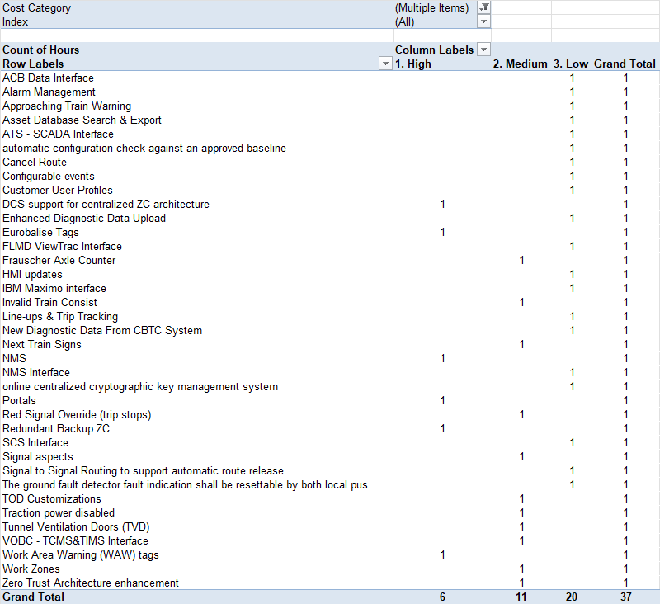

B. SOLUTION, PRODUCT POLICY AND INNOVATION
The proposed solution is fully aligned with the URS Product Policy for a GOA3 system using SelTrac CBTC. One exception is the requirement to use a Eurobalise Tag reader.
Table 1 Summary of Baseline to be used for each Subsystem
Application | Baseline | SIL | Comment
ATS | SelTrac CBTC 3.7 | Basic / 2
DCS | DCS 3.4 | Basic
ZC | SelTrac 3.7 | 4
VOBC | SelTrac 3.7 | 4
OAMS | OAMS 1.3 | Basic
Product, B/B, Ref Sol |  |  | Comment
OCUR | 2.1.0 | 4 | Or latest version in SelTrac 3.7
WPUR | 2.0.2 | 4 | Or latest version in SelTrac 3.7
OPUR | 2.4 | 4 | OPUR 2.2 is used in Seltrac 3.7. Due to Eurobalise Tag Reader, project level system/software/safety will have to incorporate this version of the platform
DCS | 3.4 | None | DCS 3.3 is used in SelTrac 3.7. An updated generic reference solution for DCS is being produced to support a centralized architecture. Project will be instantiated based on DCS 3.4
OAMS | 1.3 | Basic | The OAMS will be updated to latest versions beyond 1.3 to incorporate new generic features driven by the TTC specifications, as, OAMS is a generic sw product.

Nota: Any mitigations to hardware compliance risk could trigger a platform update. See risks.
Product / Project Dependencies
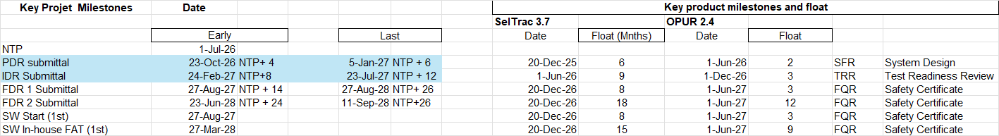
Sufficient float exist against key product deliveries.

Product HSE:
  - No gaps identified by HW compliance group.
  - “Environmental Performance File” (template 87213188-HSE-GRP-EN-002) not available for bid.

Environmental Footprint Improvement
Nothing specific for this project. Standard product V3.7 to be used.

C. SECURITY:
Are there explicit or implicit security requirements? What is the list of applicable security regulations? | Cybersecurity requirements are listed in Section 34 42 63 in the RFP. DCS and Cybersecurity standards requirements are listed in requirements 4.8.x of Section 01 41 00 in the RFP. They include: IEC 62443-3-3, CLC/TS 50701, NIST SP 800-53, NIST SP 800-82, NIST SP 800-207, FIPS 140-2, ISO/IEC 27001, ISO/IEC 27002, and APTA-SS-CCS-*.  Standard equivalency is allowed as per requirement 1.2.15 in Section 34 42 68, as the system baseline SelTrac 3.7 uses IEC 62443-3-3.  No applicable Cybersecurity regulations at the time of writing, as Canada Critical Cyber Systems Protection Act (CCSPA bill C-8) is still being proposed applicable to designated operators.
Is there a Security Management Plan? | A security management plan is required to be produced during the preliminary design review phase. Cybersecurity CDRL table from requirement 4.2.7.4 in Section 34 42 63 in the RFP provides an outline for a Cybersecurity Management Plan.  - Cybersecurity Management Plan: PDR  - Cybersecurity System Requirements: PDR, IDR  - Threat and Vulnerability Analysis and Risk Assessment Report: PDR, IDR, and FDR  - Cybersecurity Assurance and Acceptance Method Statement: PDR, IDR  - Cybersecurity Baseline Controls: IDR, FDR  - Cybersecurity Operations and Maintenance Plan: IDR, FDR  - Cybersecurity Assurance and Acceptance Report: Prior to RS
What are the risk analysis results based on the identification of high-level primary secure and protected entities, and potential threats? | There is a risk of ATS compromise via web-based ATS connected from TTC corporate network leading to unauthorized ATS command impacting operational continuity. This risk is considered within tolerance with planned mitigating controls including central user authentication, web application firewall, and with security application conditions (e.g. user training and user screening) exported to the customer.
Is the Global security architecture and protection described? How does the design cover all aspects regarding cybersecurity concerns (identification, protection, detection, response and recovery)? | Global security architecture is as per DCS 3.4, including:  - Security zones and conduit based on CLC/TS 50701, including DMZ in central to interface with external systems, and encrypted conduits including encrypted wireless communications between onboard & wayside and onboard & central;  - Encrypted communication regardless of network location  - Centralized ZC Architecture  - Unidirectional gateway  - Web application firewall for ATS incorporated in the GDP  - Test Network connectivity to revenue network  - PKI including key rotation support
Are the interfaces with external systems identified and what are the trusted and untrusted data sources? | External interfaces are listed in Section 2 above. Detail design to be implemented in the project phase.  - IP-based external systems interfacing at central are less trusted and they interface with the CBTC via DMZ, including web-based ATS from TTC Corporate network via RDS in the DMZ and also legacy ATS  - IP-based external systems at on-board are considered more trusted and interface through onboard SD (MCG).  - Non-IP based (e.g. discrete) wayside (connected to OC-UR) and onboard external systems interfaces are considered Trusted.
Define the list of Cyber Security components proposed on the project? | Cyber Security components are as per SelTrac 3.7 and DCS 3.4 product (e.g. Active Directory / RADIUS, security event collection, endpoint security, patching service, etc.,). Notable components for the TTC L2 solution: RDS in the DMZ.
Is there a legal analysis for Cyber clauses?  If YES, is ATC-GTS-NRC responsible in case of security breach and associated engagement identified in the legal memo, … | No, there is no analysis on the cyber clauses as there are no cyber clauses in the general conditions.
Is there a flow down of the security requirements to the partners/ sub-contractors/ key suppliers? | Yes, for OpenText NMS. Refer to TTC L2 DCS DVa.
Is there pen tests (factory and site) included in our proposal? | Penetration test is planned for the project for each phase.

D. SAFETY
In terms of certification, the following questions are mandatory:
What are the novelties in terms of regulation and/or design and/or mean of compliance? | The Project ISA will have to cross-accept the planned ISA certification for Product 3.7, which is scheduled for completion by Q3 2026. The same goes for OPUR 2.4 with updates for Eurobalise.  The final Project solution must be assessed by an accredited ISA and in addition to cross-acceptance of the Product 3.7 certification, it must address any delta from the scope of the Product certification.  HW mechanical design and environmental requirements require AREMA and CENELEC compliance. Will provide CENELEC certification with declaration of equivalence to AREMA. There is a risk this strategy will not be accepted.
What is the mitigation plan? | None needed
Are the skills in the development Team at the adequate level | Yes
Compliance with local entity rules (e.g. Transportation, Avionics, Space…)  DRAFT  Cyber  to update | Local entity transportation, typical list of EN, IEC, and ISO
Are all the key roles regarding certification well identified and staffed? | Yes
Are certification requirements correctly cascaded to our Partners or Design suppliers? Are they aware and committed to contribute to certification and deliver certification material? | No Partners. Suppliers to provide relevant inputs.

GTS Specific Safety related checkpoints:
What international standards are required? e.g. CENELEC/AREMA etc. | NFPA 101, NFPA 130, EN 50126, EN 50716:2023, EN 50129, IEC 61508, MIL-STD-882E, ISO/IEC/IEEE 15288, IEEE 1474.1, IEEE std 1483, MIL-STD-1629A or EN 60812, AREMA Communications & Signals Manual of Recommended Practice 2022.
Is a NoBo/ISA required by contract to be hired by customer or by supplier? | For the Metrolinx option only.
If brown field, what is the migration plan/strategy e.g. is there a migration boundary? | 6 migration stages and boundaries defined in the specification.  Migration strategy summarized in BBR slides 23&24: Hitachi-Bid-BBR-Essentials.pptx
Is the certification of baseline product(s) current for the project i.e. no change in standards and hence recertification required? Are SACs appropriate and achievable for the solution? | No. The product to be utilized is an incremental feature release of a previously certified product. Development has started on SelTrac 3.7 however product is not yet certified.  SelTrac Product V3.7 is planned to be certified by Q3 2026. Project will provide a certification covering the delta from 3.7. The SACs are expected to be appropriate and achievable but this question cannot be answered until the Product version is finalized and certified. Furthermore, the project will have to incorporate OPUR 2.4 as base solution has the Hitachi Italy Eurobalise.
What are the RAMS targets? | See tables below.
Is the Safety Certification process well identified and resourced? | Yes for internal Safety Authorization process and for ISA certification, the ISA will have to be hired and it is expected that the ISA selected will follow an established and accredited process and will be appropriately resourced.

Compliance Matrix for MTTR
Subsystem | Contract Requirements | MTTR Requirements  (Minutes) | Hitachi Rail  Predicated  MTTR (minutes) | Compliant  Y/N
ATS Equipment | The MTTR for a failed piece of in-service CBTC  System equipment either on the Wayside or ATS  first level repair shall be no greater than fifteen (15) minutes. | 15 | 16 | N
Wayside Equipment | The MTTR for a failed piece of in-service CBTC  System equipment either on the Wayside or ATS  first level repair shall be no greater than fifteen (15) minutes. | 15 | 21.5 | N
Train Borne | The MTTR of a failed piece of in-service CBTC  Train-Borne equipment installed within the CBTC  locker shall be no greater than twenty (20) minutes | 20 | 19 | Y
Train Borne | The MTTR of a failed piece of in-service CBTC  Train-Borne equipment installed either on the  axle or car body shall be no greater than thirty (30) minutes. | 30 | 19 | Y

Compliance Matrix for MTBF & MTBFF
 | Contract Reliability Requirements |  |  | Hitachi Rail  Predicted Reliability |  | Compliant
Subsystem | Contract Requirements | MTBF  (hours) | MTBFF  (hours) | MTBF  (hours) | MTBSAF  (hours) | Y/N
Train-Borne CTBC | Each Train-Borne equipment unit shall have a MTBF of no less than 10,000 hours and MTBFF of no less than 350,000 hours | 10,000 | 350,000 | 10,564 | 22,319,633 | Y
Train-to-Wayside Data Communication Link (RF link) | All Wayside and Train-Borne antennas and RF communication devices to allow data transmission between one equipped train and a Wayside Controller. In case the Wayside communication equipment is independent from the Wayside Controller, these targets should apply to a typical communication coverage zone. | 50,000 | 1,000,000 | 53,090 | 563,716,741 | Y
ATS | These targets apply to each ATS set of equipment (ex: workstation, status board). The MTBFF only applies to the equipment whose failures can impact the availability  (workstation, servers) | 10,000h | 50,000h | 4,808 | 46,493,275 | Only Compliant for MTBFF Requirement
DCS | The MTBF applies to each set of equipment in DCS including RF link. Whereas MTBFF applies to the entire network. | 100,000h | 1,000,000h | 173,913 | 2,563,199 | Y
Wayside (including Interlocking subsystem) CBTC | One full set of Wayside (including Interlocking subsystem) CBTC equipment | 50,000h | 1,000,000h | 5,322 | 1,804,141 | Only Compliant for MTBFF Requirement

E. HUMAN FACTORS, ENVIRONMENTAL CONDITIONS, LEGAL CONSTRAINTS AND PERFORMANCE
Who are the users, operators and maintainers?  Is there a high-level description of the human profiles covering the physiological, anthropometrical and psychological characteristics (e.g. needed competencies, working environment and condition, workload and cognitive load)? | Existing trained experienced TTC staff.
Are there some environmental, social, cultural and regulatory constraints (e.g. doctrines, directives for sustainability General Data Protection Regulation, export control)? | Province of Ontario, Municipal Freedom of Information and Protection of Privacy Act  ISO, IEC, NIST, FIPS & APTA Cybersecurity and Privacy Protection standards  Canadian Environmental Protection Act  TTC's "RESPECT AND DIGNITY POLICY",  "WORKPLACE VIOLENCE POLICY" and "FITNESS FOR DUTY POLICY – EXPECTATION FOR CONTRACTORS PROCEDURE",  "WHISTLE BLOWER REPORTING AND PROTECTION POLICY",  "CODE OF CONDUCT POLICY",  CRIMINAL MISCONDUCT POLICY"  Specification section 01 41 00 REGULATORY REQUIREMENTS lists local/Canadian regulatory standards
Is there a high-level description of the effectiveness and performance of the solution (e.g. description of the quality of service, description of the critical paths to achieve operational missions, objectives and effects)? | A performance analysis has been done to ensure we can meet the headway and travel time requirements.

F. ENGINEERING COVERAGE AND SPECIAL EXPERTISE:
F.1. Engineering approach
The project is a complex brownfield with a prescriptive specification. Due to these factors, a Model B/C approach will taken where the project will branch from the SelTrac CBTC 3.7 baseline to implement project specific features. The engineering team will be responsible for the project development and deployment.

The exceptions are the internal generic products / components, which follow a re-use model E. For these generic components features funded by this project will be rolled-into the release thereby making them available for future projects.
- Operational Asset Management System (OAMS) for diagnostics and health management.
- On-Board Platform Urban Rail (OPUR) and its components (eg TOP)
- Wayside Platform Urban Rail (WPUR)
- Data Communication system and its components (WAN, RAN, Data Centre, MCG)

A common development process and toolset shall be used for both the product and project teams, current process in effect is that used by the SelTrac CBTC V3.7 baseline. Process changes / tuning to improve efficiency or address auditor findings shall be mutually agreed on and formalized in the development plans ahead of start of development. The currently envisioned process and tooling updates includes: 1) Increase of test automation 2) Increased used of Agile methods.

F.2. Special expertise
Expertise from Hitachi European units (Italy or Austria) will be required for integration of the Eurobalise tag reader.
F.3. Deployment

GTS: Specific Field Deployment related checkpoints
Customer has proposed 6 geographical phases for the installation, testing and commissioning and cutover of Line 2. Revenue is planned in 6 stages as follows:
Phase 1: Kennedy to Main Street including Central, MTT in Greenwood, and radio coverage in Greenwood Yard
Phase 2: Main Street to Donlands (including Greenwood Wye and Hostler Platforms)
Phase 3: Donlands to Yonge
Phase 4: Yonge to Bathhurst
Phase 5: Bathurst to High Park
Phase 6: High Park to Kipling

Each migration area will have a dedicated ZC to facilitate testing with mimimal impact in the areas that have already been commissioned. The system will have external ATS to CSS(legacy ATS) and Interlocking interfaces at the migration boundaries for train transfers between the CBTC and the existing Line 2 legacy systems.
Cutover cubicles (COC) will be used in each SER to facilitate testing and commissioning.

An integrated project schedule has been prepared at bid time.
F.4. Maintainability & Supportability
A 5 year LTS contract is optional. HMS 2.0 and OAMS 1.3 components will be used.
OAMS and second line tools will be delivered to support maintenance. In addition, DCS diagnostics will be enhanced with telemetry cata from the MCGs and an integrated NMS. The Frauscher axle counter system has the FDS diagnostic system.
LCC analysis has been performed for the service team to assess the long term maintenance costs.
LTS contract and is specifics are detailed under a separate Dva.
F.5. Engineering Environment and Lifecycle Management Ecosystem
No information provided – Not Assessed.

G. SCHEDULE, WORKLOAD AND COST:
The following is the high-level project roadmap as of August 26, 2025:
Link: https://urbanandmainlines.sharepoint.com/:x:/r/sites/CA-GTS-URSBids/Shared%20Documents/Individual%20Bid%20Folders/NORAM/CANADA/TORONTO/TTC/TTC%20Line%202/50.40%20Schedule/TTC%20Line%20II%20Final%20Roadmap%20V01%20-%20In%20progress.xlsb?d=w690fb1e26a5e46d68d326ac9e22df367&csf=1&web=1&e=KJahu4

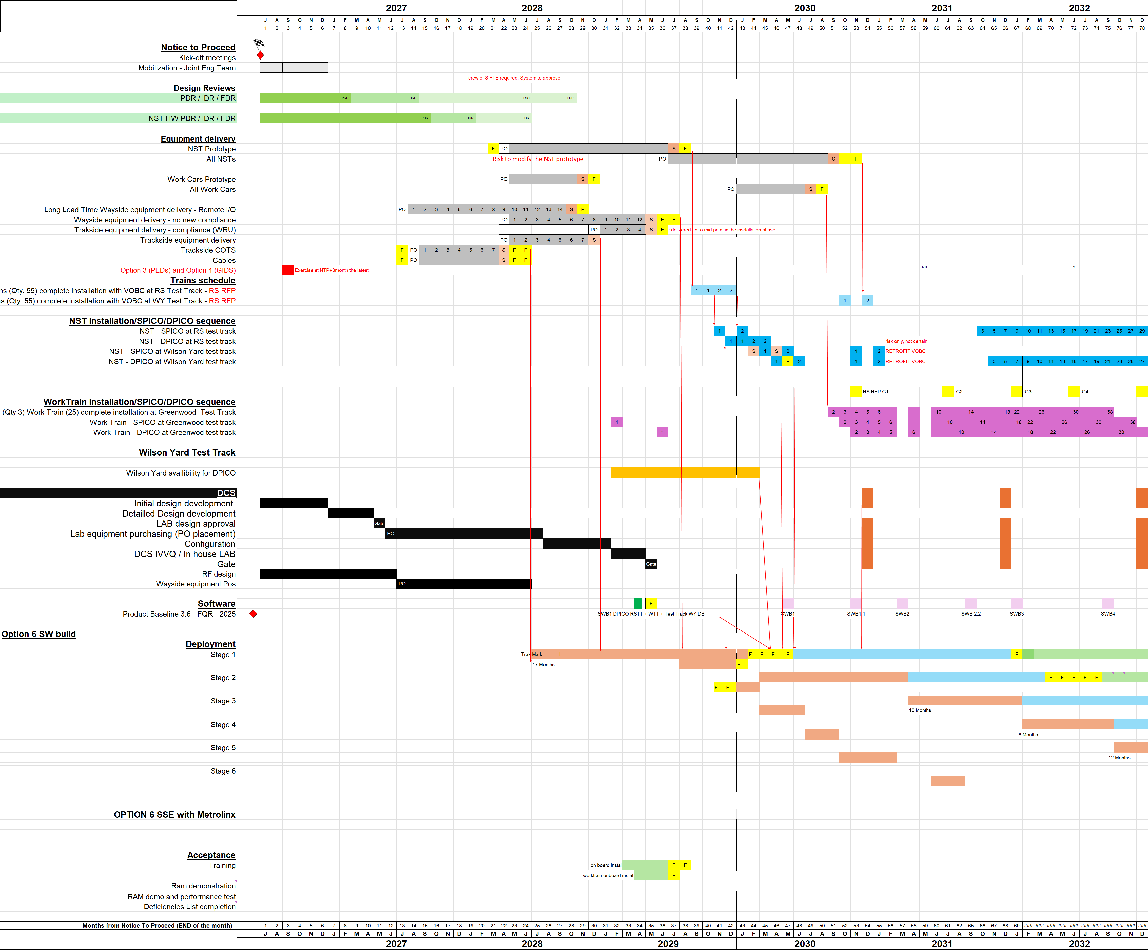Figure 3 : High Level Project Roadmap

The project costs in hours are detailed below and reflect status at DVa completion and prior to any Gate 2 updates.
 | SRS CBTC Solutions Toronto (Hrs) | Low Cost Center (Hrs) | Total (Hrs)
RC | 608 255 | 92 745 | 701 000
NRC | 79 154 |  | 79 154
CFRD | 13 591 |  | 13 591
Total | 701 000 | 92 745 | 793 745

Note: Indicative only, there are minor updates occurring at time of Dva signature.

Figure 4 : Labour Summary

H. RISKS/OPPORTUNITIES:
Risk register is in: 50.60 Risk Opportunity
Current version is rev 5: TTCL2_Risk_Register_Rev005_Base.xlsm
TOP RISKS

- Additional design iterations, SW releases due to TTC having different interpretations of requirements and being extremely particular, overcritical and unyielding in acceptance of inconsequential deviations.
- Work Car design cost due to complexity greater than assumed and needing more than 2 types of Work Car design.
- Long duration of project results in costly obsolescence issues before final system acceptance.
- Cross acceptance (request for standards equivalency) for rack design, cabling, EMI and overall standards compliance may not be accepted by TTC.
- Increase in warranty and service costs due to delays in acceptance, actual costs of third party warranty agreements, increases in COTS annual licensing and service fees.
- Additional cost for team mobilization if cutover cannot be completed 1 year early (assumed for estimating).
- There are 2 Customers (TTC, Metrolinx) if the SSE extension is exercised. There is a risk of commercial, technical, and, schedule conflicts especially if SSE extension starts prior to final completion of TTC L2.
- Station stopping performance may be unattainable without additional equipment.
- First project with 4x2oo2 Zone Controller centralized using NMR redundancy mechanism. Risk on availability due to performance of direct fiber link between each geo-redundant 2x2oo2 ZCs. The use of high quality SFPs are recommended due to non-tolerance of packet loss on this link.
- Additional work / complexity to interface to Eurobalise tag reader.

OPPORTUNITES
- Options include additional trains
- Depot resignaling for GoA4 in the future​
- Lower ATS effort by convincing TTC to use existing HMI instead of adding old Alstom features
- Variation order for implementing PEDs on SSE since TTC has (accidentally?) removed it from the revised specification
- 3 or 4 stages rather than 6 to be discussed with customer providing material and labor savings.
- DCS one shot Data Communication system deployment using Network-in-a-Box improving overall project efficiency
- Use of Hitachi Field Device Controller instead of OCCUR to avoid relays to switch machines.
- Additional services possible via the 5G Network.
- Material list has optimizations – detailed review needed.
- Convincing the Customer that an integrated NMS is not required and omit the OpenText subcontract and related internal development hours.

SUMMARY, DECISION & ACTION PLAN

DVa «VALIDATED with Action Plan»:

Actions to be addressed for Gate 2:

- Decide on incorporating Hitachi Vienna Eurobalise to save platform dev costs (approximately 3 MCad savings).
- Finish the compliance assessment outline clear plan for non-compliances and smart compliances. Producing a grouping to ensure. Put the listing in an Appendix (Excel File preferred)



- The bid has not taken into account Arema requirements which are required as part of the RFP. Recommend to have the following to balance compliance with competitiveness.
- Provide in the project cost a nominally Arema compliant solution – after all, most of our platforms and equipment being delivered for Crosstown meets Arema.
- For the remaining non-compliances, put the cost-comply in risk.
- Ensure a complete and detailed estimate for the work needed ‘to comply’.
- Additional float to be built into the schedule in particular for initial PDR and IDR milestones. The CDRL list to be reviewed to ensure reasonable and appropriate (for the phase) are allocated to these milestones.
- Resolve the discrepancies in the feature list and their related estimates. Resubmit the feature list Excel with 2 pivot tables for final review and Design Authority approval.
- Include in conditions of offer: Responsibility for the private frequency license is with Customer.
- Minor cleanup: Architecture diagram change from Cisco Radio to 5G radio.
  - Completed (GH, Sept 18)

"if any above decision or action is not closed in due time, the present DVa becomes NOT VALIDATED"

Main points of attention for Gate 2:
- Complex brownfield with multi-stage (6) migration; several boundary zones; long project duration
- Prescriptive specification; consultant-influenced; requirements exceed needs (eg 4 x2oo2 ZC)
- System is GOA3 but will likely operate in GOA2, work trains, 5G Data Comms (3900-3980 Mhz NCLL framework)
- First SelTrac CBTC project to use Eurobalise for positioning; Customer imposed; Impact to On-Board platform due to reader choice (See Action Plan]
- First SelTrac CBTC with geo-redundancy and 4x2002 ZCs; technical risk.
- Challenging station stopping performance requirements; may not be attainable.
- Compliance assessment not fully completed at time of Dva [See Action Plan]
- Comprehensive cyber security requirements
- Comprehensive Diagnostic and Maintenance System (UDMS)
- Two important follow-on contracts (Speed Control System: 70 trains + Scarborough extension). Hitachi is the designated supplier for these.
- CDRL List has a lot of documents at PDR, looks like over-commit early in project. [See Action Plan]
- Known local Customer; Local content is a key objective.
- Proposal needs to be fully compliant; completion + greater clarity required on the compliance [See Action Plan]

Main outcomes of DA assessment
1-Technical solution
Compliance to Product Policy | The project is compliant to Product Policy using the SelTrac CBTC 3.7 baseline and its associated platforms with the exception of Eurobalise tag reader which is outside of the product policy.
Compliance to Customer RFQ | The compliance analysis has not been completed (see Dva actions). Furthermore, there are several non-compliances and strategic compliances identified that require a documented approach / mitigation plan.
Technical approach | Due to the prescriptive requirements in the RFP and the fact this is a lengthy multi-stage brownfield project, it will be handled fully by the engineering team. It is classified as a model B/C reuse and will branch from the SelTrac CBTC v3.7 baseline. The exceptions will be internal products / components already managed as generic products: OCCUR, OPUR, TOP, OAMS, WPUR, DCS, MCG which will be managed by their respective product development teams.  The technical approach keeps a clean separation between product/project facilitating a smooth execution.  The important / critical new features are  - DCS support for centralized ZC architecture  - Eurobalise interface and updates to positioning component  - Portals and management of migration boundaries  - Geo-redundant 2x2oo2 ZCs  - Work Area Warning (WAW) tags  - Zero Trust Architecture enhancements
RAM & Safety | An independent ISA will be hired by the Customer (for base) and by Metrolinx (SSE contract); project is based on cross-acceptance of the product baseline which will have a Safety certification. Cenelec and AREMA standards are appliable. The Safety team shall provision for a new release of OPUR to be inserted directly in the TTC L2 project stream without going to solution level (SelTrac CBTC) product stream. OPUR 2.4 shall contain the Eurobalise updates.  Initial calculations show we generally comply with MTBSAF. We do not comply to all MTBF and MTTR.
Cyber-Security | The are numerous & demanding cyber security requirements. Based on our other projects, this is a knowledgeable Customer well equipped with consultants. Our cyber security plan will be based on zoning and IEC 62443 and Cenelec EN 50701 standards.
Services | Patching is required for the Capex contract and ensuring that software is updated prior to revenue service.
Human Factors | A human factors study is required.
Compliance to mandatory regulations | There are numerous standards and regulations in the RFP. We comply to most or provide an equivalency. The Customer has the right to accept or deny requests for equivalency.
Environmental Footprint (Eco-design) | Eco-design will follow the product SelTrac CBTC eco design.
2-Capacity to deliver
Engineering, deployment & service resources | There are sufficient engineering resources with a start of 1-July-2026 based on company Labour Forecast Report. Due to the brownfield nature and challenging requirements, it is essential that the core team be selected from experienced staff ahead of the project to ensure a successful start.
Planning | The overall planning is adequate for the project. However the initial dates for PDR, IDR do not have sufficient float. (See Dva actions)
Cost estimates (NRC/RC) | The NRC/RC is assessed as adequate for the works, it represents an average loading of 32 FTE (non-LCC) for the duration of the project (~12 years).  There are significant recurring costs due to product duration and recurrent-variable due to, for example, maintenance vehicles.
Dependencies from product policy | There is no SFRD allocated for this project. There are the following dependencies on product policy:  Completion of SelTrac 3.7 – Q3 2026.  Completion of OPUR 2.4. Q3 2027.
Customer / third party dependencies | Dependency on Customer for site access (brownfield)
Specific engineering processes & know-how transfers | The team will need to gain knowledge of the usage of Eurobalise reader from our European colleagues.
Obsolescence | No known obsolescence’s however due to length of the project, components may become obsolete during the project execution.
3-Risks & Opportunities
Risks | Risks are commensurate with complex brownfield multi-stage cutover, demanding customer and prescriptive RFP. The main technical risk are  1. Meeting station stopping performance < 1/70000 outside the 20-40 cm window.  2. Availability of the 4 x 2oo2 geo-redundant Zone Controllers.
Opportunities | Several opportunities, see DVa section.

Appendix A: Trackside Devices
[Not Validated and needs cross-check against final equipment list]
Device | Quantity, Line 2 | Quantity, SSE | New/Existing
Switch machines | 92 | 12 | Existing
Signals, buffer stop | 6 | 4 | New
Signals, 3 aspect | 205 | 26 | New
PPI | 76 | 12 | New
Trip Stops | 205 | 26 | New
Axle Counters | 316 | 56 | New

END OF DOCUMENT

